CIS 5200 – Final Instructions
Analysis of U.S. Used Car Market Trends Using Hadoop and Hive
Team 1: Brenda Beltran, Edward Salame, Thelma Eremionkhale

Objectives
In this hands-on lab, you will learn how to:
- Upload dataset to HDFS
- Create table on beeline
- Clean data using HiveQL
- Create summary tables in order to build visualizations.
- Export results of summary tables into csv files
- Build visualizations using Power BI and Excel.

Platform Spec
- Hadoop Cluster version: hadoop 3.4.1
- Beeline version: Beeline version 3.1.3
- Number of nodes: 5
- HDFS Capacity: 390.17GB
- OCPUs: 6
- Memory: 31GiB
- Storage: 390.2GB
- CPU speed: 2445.354
- CPU Model Name: AMD EPYC 7J13 64-Core Processor

Code to view platform specifications
Hadoop cluster version

Beeline version
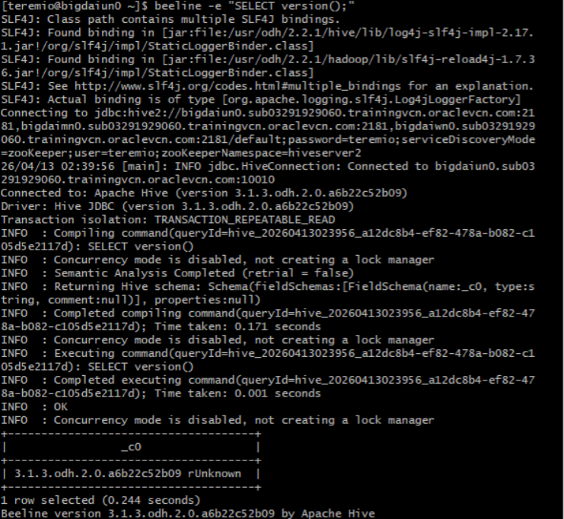

Number of nodes
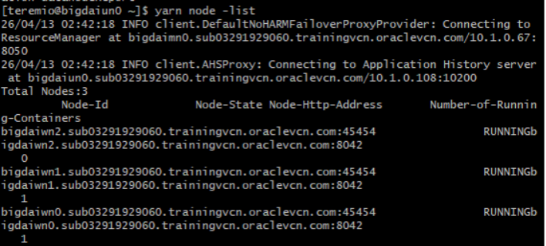
HDFS capacity
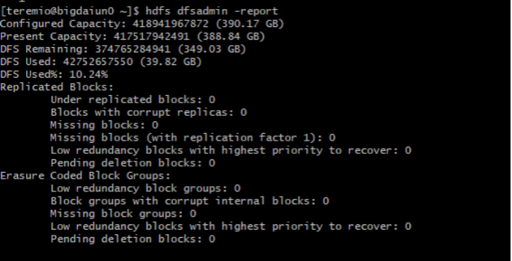

OCPUs, CPU speed, CPU Model Name
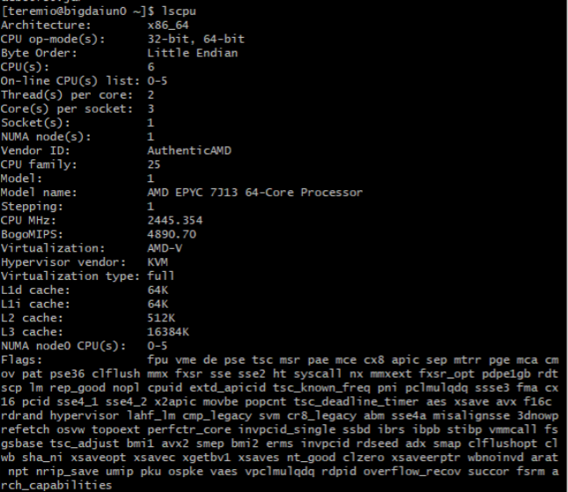

Memory
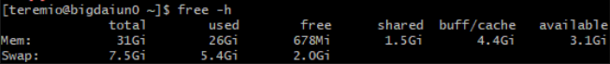

HDFS Storage
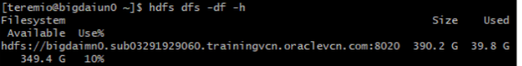

1. Download dataset in Local Machine
Step 1: Download the dataset in your local machine
Click on the dataset link (linked in references) and click the Download button to download the file into your PC.
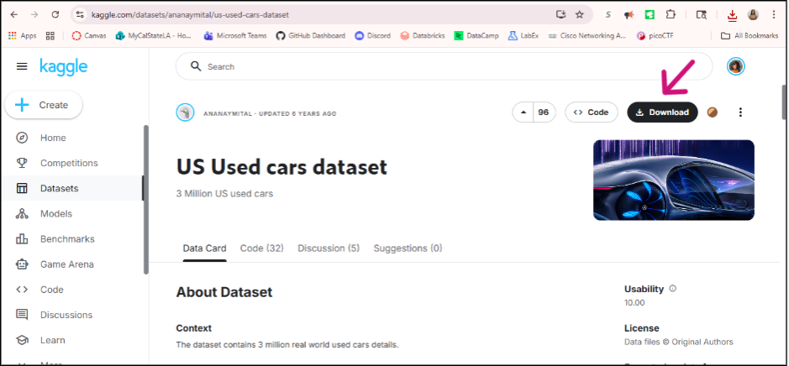

Download dataset as a zip file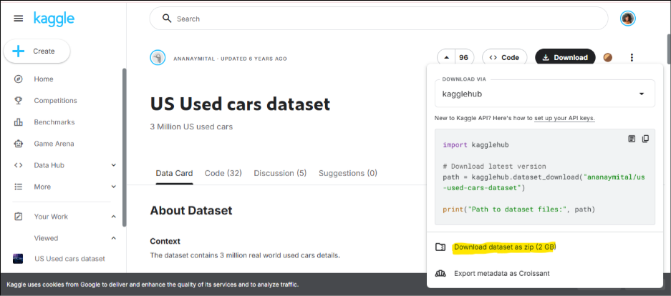

Open your File explorer. The file should be on your pc as “archive.zip”
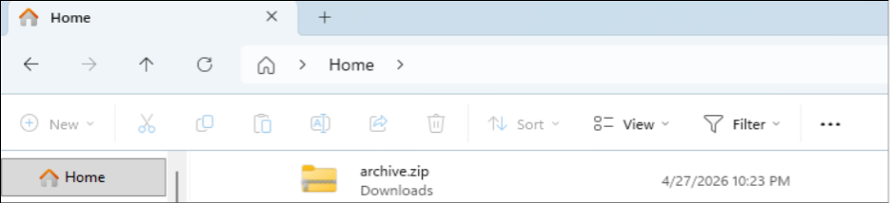

2. Analysis using Hadoop and Hive
-- STEP 1: Run on LOCAL machine CLI
cd downloads
scp archive.zip teremio@132.226.148.236:/tmp
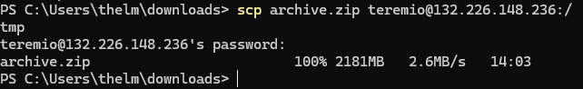
-- STEP 2: SSH into server
ssh teremio@132.226.148.236

-- Confirm file is there
ls -lh /tmp

-- Unzip
unzip /tmp/archive.zip -d /tmp
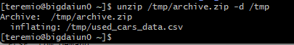

-- Confirm CSV exists before doing anything else
ls -lh /tmp

-- Upload to HDFS
hdfs dfs -mkdir /tmp/car
hdfs dfs -put /tmp/used_cars_data.csv /tmp/car
hdfs dfs -ls /tmp/car

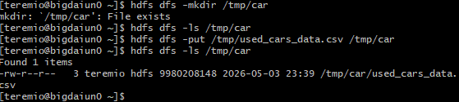

-- Confirm CSV is in HDFS then delete from server
rm /tmp/archive.zip
rm /tmp/used_cars_data.csv

-- STEP 3: Connect to Hive and Create External Table--
ssh teremio@132.226.148.236
beeline
use teremio;

DROP TABLE IF EXISTS used_cars_raw;

CREATE EXTERNAL TABLE used_cars_raw (
vin STRING, back_legroom STRING, bed STRING, bed_height STRING,
bed_length STRING, body_type STRING, cabin STRING, city STRING,
city_fuel_economy STRING, combine_fuel_economy STRING, daysonmarket STRING,
dealer_zip STRING, description STRING, engine_cylinders STRING,
engine_displacement STRING, engine_type STRING, exterior_color STRING,
fleet STRING, frame_damaged STRING, franchise_dealer STRING,
franchise_make STRING, front_legroom STRING, fuel_tank_volume STRING,
fuel_type STRING, has_accidents STRING, height STRING,
highway_fuel_economy STRING, horsepower STRING, interior_color STRING,
isCab STRING, is_certified STRING, is_cpo STRING, is_new STRING,
is_oemcpo STRING, latitude STRING, length STRING, listed_date STRING,
listing_color STRING, listing_id STRING, longitude STRING,
main_picture_url STRING, major_options STRING, make_name STRING,
maximum_seating STRING, mileage STRING, model_name STRING,
owner_count STRING, power STRING, price STRING, salvage STRING,
savings_amount STRING, seller_rating STRING, sp_id STRING,
sp_name STRING, theft_title STRING, torque STRING, transmission STRING,
transmission_display STRING, trimId STRING, trim_name STRING,
vehicle_damage_category STRING, wheel_system STRING,
wheel_system_display STRING, wheelbase STRING, width STRING, year STRING
)
ROW FORMAT SERDE 'org.apache.hadoop.hive.serde2.OpenCSVSerde'
WITH SERDEPROPERTIES (
"separatorChar" = ",",
"quoteChar" = "\"",
"escapeChar" = "\\"
)
STORED AS TEXTFILE
LOCATION '/tmp/car'
TBLPROPERTIES ("skip.header.line.count"="1");

-- View your table--
SELECT * FROM used_cars_raw LIMIT 5;
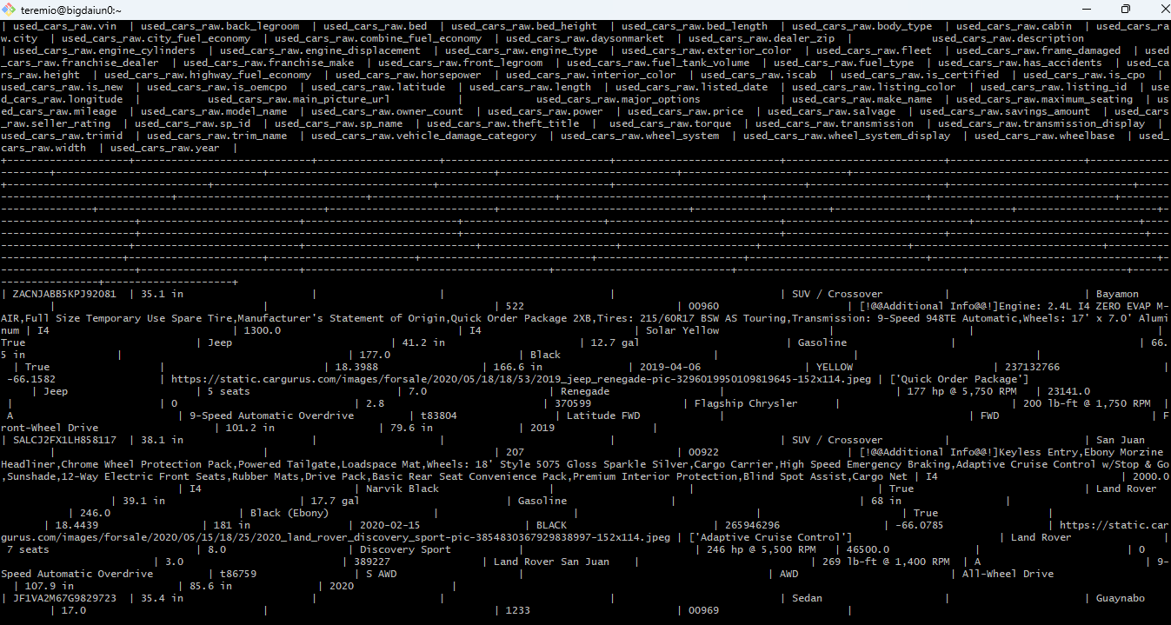
DESCRIBE FORMATTED used_cars_raw;
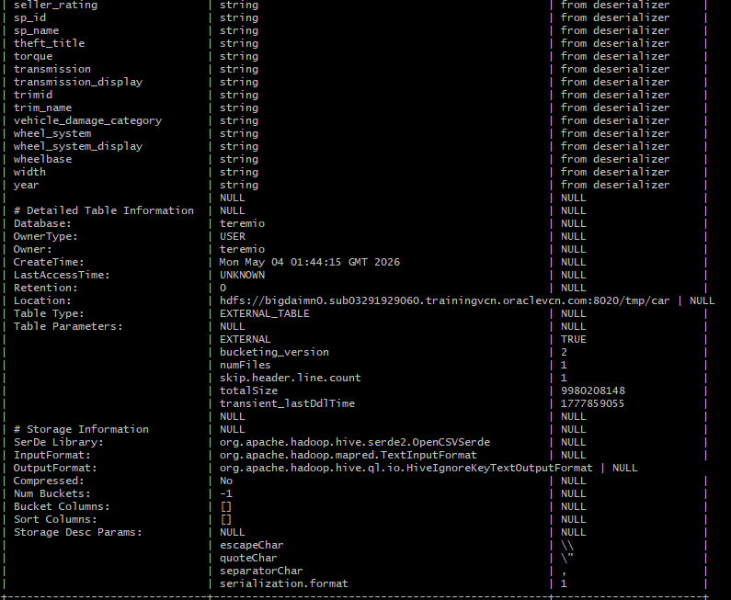

-- STEP 4: Create Clean Table--
DROP TABLE IF EXISTS used_cars_clean;
CREATE TABLE used_cars_clean AS
SELECT
CAST(latitude AS DOUBLE) AS latitude,
CAST(longitude AS DOUBLE) AS longitude,
city,
YEAR(TO_DATE(listed_date)) AS listing_year,
MONTH(TO_DATE(listed_date)) AS listing_month,
CAST(daysonmarket AS INT) AS days_on_market,
CASE
WHEN CAST(daysonmarket AS INT) <= 20 THEN 'High Demand'
WHEN CAST(daysonmarket AS INT) <= 45 THEN 'Medium Demand'
ELSE 'Low Demand'
END AS demand_category,
make_name,
fuel_type,
CAST(price AS DOUBLE) AS price,
CAST(mileage AS DOUBLE) AS mileage,
CASE
WHEN has_accidents = 'True' THEN true
ELSE false
END AS has_accidents
FROM used_cars_raw
WHERE
price IS NOT NULL
AND CAST(price AS DOUBLE) > 500
AND latitude IS NOT NULL
AND longitude IS NOT NULL
AND listed_date IS NOT NULL
AND make_name IS NOT NULL
AND daysonmarket IS NOT NULL
AND fuel_type IS NOT NULL
AND has_accidents IS NOT NULL
AND mileage IS NOT NULL
AND CAST(mileage AS DOUBLE) > 0
LIMIT 500000;

-- Verify clean table--
SELECT * FROM used_cars_clean LIMIT 5;
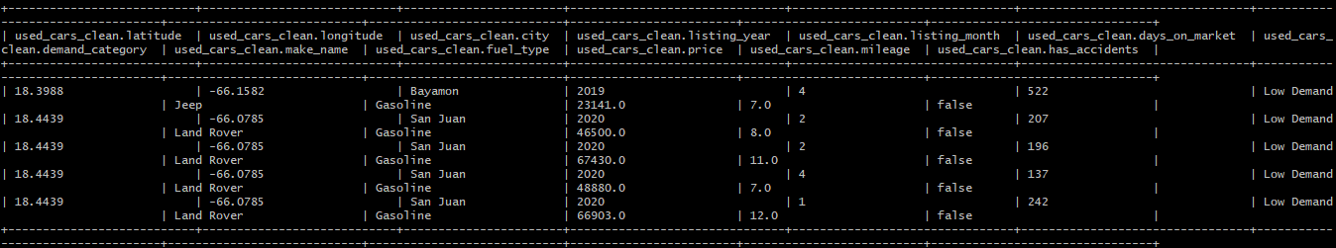
DESCRIBE FORMATTED used_cars_clean;
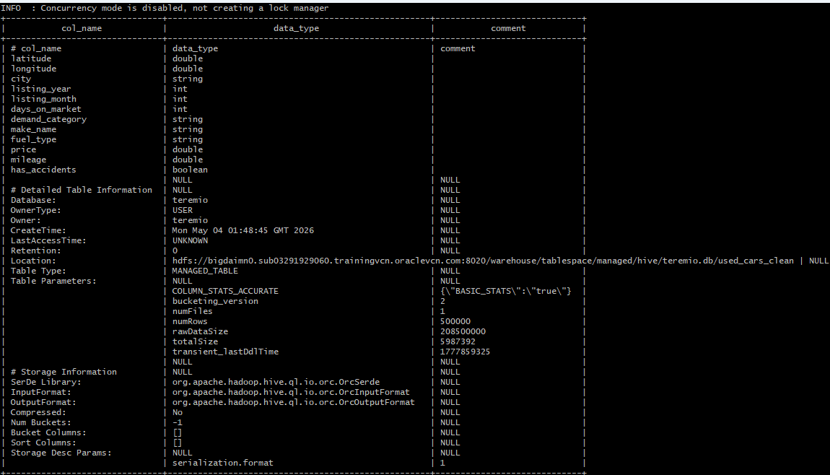

-- QUERY 1 : Demand by Fuel Type Over Time--
SELECT
TRIM(fuel_type) AS fuel_type,
listing_year,
COUNT(*) AS total_listings,
ROUND(AVG(days_on_market), 1) AS avg_days_on_market
FROM used_cars_clean
WHERE
listing_year >= 2016
AND fuel_type IS NOT NULL
AND TRIM(fuel_type) <> ''
AND days_on_market IS NOT NULL
GROUP BY
TRIM(fuel_type),
listing_year
HAVING
COUNT(*) >= 50
ORDER BY
listing_year,
total_listings DESC
LIMIT 20;
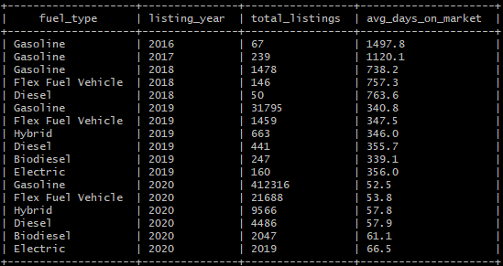

-- QUERY 2 : Accident History Impact on Price and Demand--
SELECT
has_accidents,
COUNT(*) AS total_listings,
ROUND(AVG(price), 2) AS avg_price,
ROUND(AVG(days_on_market), 1) AS avg_days_on_market
FROM used_cars_clean
GROUP BY
has_accidents
ORDER BY
avg_price DESC;
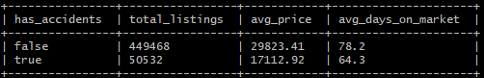

-- QUERY 3 : Top 10 Used Car Brands in the US--
SELECT
make_name,
COUNT(*) AS total_listings,
ROUND(AVG(days_on_market), 1) AS avg_days_on_market
FROM used_cars_clean
GROUP BY
make_name
HAVING
COUNT(*) >= 500
ORDER BY
avg_days_on_market ASC,
total_listings DESC
LIMIT 10;
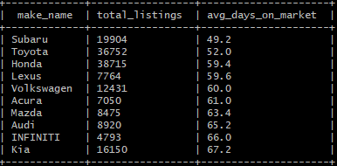

-- QUERY 4 : Distribution of Car Sales by State (Spatial)--
SELECT
city,
ROUND(latitude, 4) AS latitude,
ROUND(longitude, 4) AS longitude,
COUNT(*) AS total_listings,
ROUND(AVG(price), 2) AS avg_price,
ROUND(AVG(days_on_market), 1) AS avg_days_on_market
FROM used_cars_clean
GROUP BY
city,
ROUND(latitude, 4),
ROUND(longitude, 4)
ORDER BY
total_listings DESC
LIMIT 20;
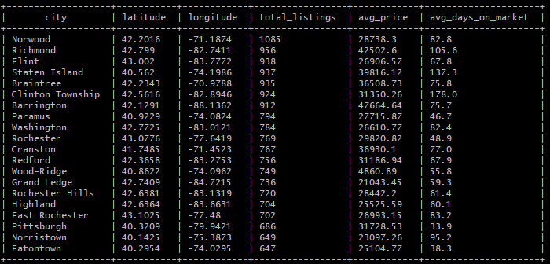

-- QUERY 5 : Tempo-Spatial Seasonal Trends by Month and Location--
SELECT
city,
ROUND(latitude, 4) AS latitude,
ROUND(longitude, 4) AS longitude,
CONCAT(listing_year, '-',
LPAD(CAST(listing_month AS STRING), 2, '0'),
'-01') AS listing_date,
COUNT(*) AS total_listings,
ROUND(AVG(days_on_market), 1) AS avg_days_on_market,
demand_category
FROM used_cars_clean
GROUP BY
city,
ROUND(latitude, 4),
ROUND(longitude, 4),
CONCAT(listing_year, '-',
LPAD(CAST(listing_month AS STRING), 2, '0'),
'-01'),
demand_category
ORDER BY
listing_date,
total_listings DESC
LIMIT 20;
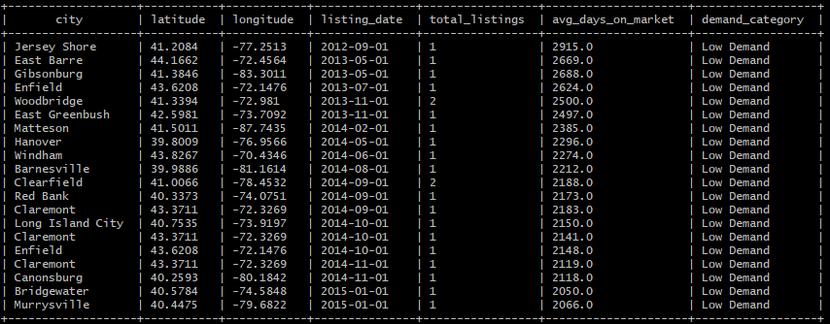
-- QUERY 6 : Average price by fuel type and mileage--
SELECT
TRIM(fuel_type) AS fuel_type,
CASE
WHEN mileage < 20000 THEN '0-20k'
WHEN mileage < 40000 THEN '20k-40k'
WHEN mileage < 60000 THEN '40k-60k'
WHEN mileage < 80000 THEN '60k-80k'
WHEN mileage < 100000 THEN '80k-100k'
ELSE '100k+'
END AS mileage_bucket,
COUNT(*) AS total_listings,
ROUND(AVG(price), 2) AS avg_price,
ROUND(AVG(mileage), 0) AS avg_mileage
FROM used_cars_clean
WHERE
mileage IS NOT NULL
AND mileage > 0
AND fuel_type IS NOT NULL
AND TRIM(fuel_type) <> '' -- removes empty strings
AND TRIM(fuel_type) <> 'N/A' -- removes N/A values just in case
GROUP BY
TRIM(fuel_type),
CASE
WHEN mileage < 20000 THEN '0-20k'
WHEN mileage < 40000 THEN '20k-40k'
WHEN mileage < 60000 THEN '40k-60k'
WHEN mileage < 80000 THEN '60k-80k'
WHEN mileage < 100000 THEN '80k-100k'
ELSE '100k+'
END
ORDER BY
fuel_type,
avg_mileage ASC
LIMIT 20;
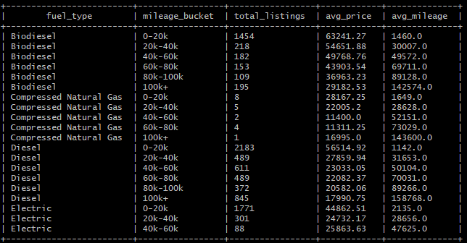

-- STEP 6: Export All Queries to CSV--

-- EXPORT QUERY 1: Demand by Fuel Type Over Time
INSERT OVERWRITE DIRECTORY '/tmp/teremio/fueltype_demand'
ROW FORMAT DELIMITED FIELDS TERMINATED BY ','
SELECT
TRIM(fuel_type) AS fuel_type,
listing_year,
COUNT(*) AS total_listings,
ROUND(AVG(days_on_market), 1) AS avg_days_on_market
FROM used_cars_clean
WHERE
listing_year >= 2016
AND fuel_type IS NOT NULL
AND TRIM(fuel_type) <> ''
AND days_on_market IS NOT NULL
GROUP BY
TRIM(fuel_type),
listing_year
HAVING
COUNT(*) >= 50
ORDER BY
listing_year,
total_listings DESC;

-- EXPORT QUERY 2: Accident History Impact on Price and Demand
INSERT OVERWRITE DIRECTORY '/tmp/teremio/accident_impact'
ROW FORMAT DELIMITED FIELDS TERMINATED BY ','
SELECT
has_accidents,
COUNT(*) AS total_listings,
ROUND(AVG(price), 2) AS avg_price,
ROUND(AVG(days_on_market), 1) AS avg_days_on_market
FROM used_cars_clean
GROUP BY
has_accidents
ORDER BY
avg_price DESC;

-- EXPORT QUERY 3: Top 10 Used Car Brands in the US
INSERT OVERWRITE DIRECTORY '/tmp/teremio/top_brands'
ROW FORMAT DELIMITED FIELDS TERMINATED BY ','
SELECT
make_name,
COUNT(*) AS total_listings,
ROUND(AVG(days_on_market), 1) AS avg_days_on_market
FROM used_cars_clean
GROUP BY
make_name
HAVING
COUNT(*) >= 500
ORDER BY
avg_days_on_market ASC,
total_listings DESC
LIMIT 10;

-- EXPORT QUERY 4: Distribution of Car Sales by State (Spatial)
INSERT OVERWRITE DIRECTORY '/tmp/teremio/sales_by_state'
ROW FORMAT DELIMITED FIELDS TERMINATED BY ','
SELECT
city,
ROUND(latitude, 4) AS latitude,
ROUND(longitude, 4) AS longitude,
COUNT(*) AS total_listings,
ROUND(AVG(price), 2) AS avg_price,
ROUND(AVG(days_on_market), 1) AS avg_days_on_market
FROM used_cars_clean
GROUP BY
city,
ROUND(latitude, 4),
ROUND(longitude, 4)
ORDER BY
total_listings DESC;

-- EXPORT QUERY 5: Tempo-Spatial Seasonal Trends by Month and Location
INSERT OVERWRITE DIRECTORY '/tmp/teremio/seasonal_trends'
ROW FORMAT DELIMITED FIELDS TERMINATED BY ','
SELECT
city,
ROUND(latitude, 4) AS latitude,
ROUND(longitude, 4) AS longitude,
CONCAT(listing_year, '-',
LPAD(CAST(listing_month AS STRING), 2, '0'),
'-01') AS listing_date,
COUNT(*) AS total_listings,
ROUND(AVG(days_on_market), 1) AS avg_days_on_market,
demand_category
FROM used_cars_clean
GROUP BY
city,
ROUND(latitude, 4),
ROUND(longitude, 4),
CONCAT(listing_year, '-',
LPAD(CAST(listing_month AS STRING), 2, '0'),
'-01'),
demand_category
ORDER BY
listing_date,
total_listings DESC;

-- EXPORT QUERY 6: Average price by fuel type and mileage
INSERT OVERWRITE DIRECTORY '/tmp/teremio/fuel_mileage'
ROW FORMAT DELIMITED FIELDS TERMINATED BY ','
SELECT
TRIM(fuel_type) AS fuel_type,
CASE
WHEN mileage < 20000 THEN '0-20k'
WHEN mileage < 40000 THEN '20k-40k'
WHEN mileage < 60000 THEN '40k-60k'
WHEN mileage < 80000 THEN '60k-80k'
WHEN mileage < 100000 THEN '80k-100k'
ELSE '100k+'
END AS mileage_bucket,
COUNT(*) AS total_listings,
ROUND(AVG(price), 2) AS avg_price,
ROUND(AVG(mileage), 0) AS avg_mileage
FROM used_cars_clean
WHERE
mileage IS NOT NULL
AND mileage > 0
AND fuel_type IS NOT NULL
AND TRIM(fuel_type) <> ''
AND TRIM(fuel_type) <> 'N/A'
GROUP BY
TRIM(fuel_type),
CASE
WHEN mileage < 20000 THEN '0-20k'
WHEN mileage < 40000 THEN '20k-40k'
WHEN mileage < 60000 THEN '40k-60k'
WHEN mileage < 80000 THEN '60k-80k'
WHEN mileage < 100000 THEN '80k-100k'
ELSE '100k+'
END
ORDER BY
fuel_type,
avg_mileage ASC;

-
-- STEP 7: Pull files from HDFS to server home directory
hdfs dfs -get /tmp/teremio/fueltype_demand/000000_0 fueltype_demand.csv
hdfs dfs -get /tmp/teremio/accident_impact/000000_0 accident_impact.csv
hdfs dfs -get /tmp/teremio/top_brands/000000_0 top_brands.csv
hdfs dfs -get /tmp/teremio/sales_by_state/000000_0 sales_by_state.csv
hdfs dfs -get /tmp/teremio/seasonal_trends/000000_0 seasonal_trends.csv
hdfs dfs -get /tmp/teremio/fuel_mileage/000000_0 fuel_mileage.csv
ls -lh
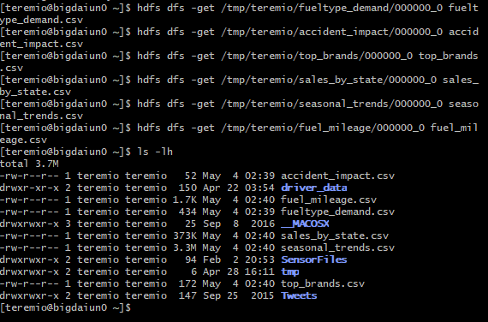

-- STEP 8: SCP files to your local machine (run on LOCAL CLI)--
scp teremio@132.226.148.236:~/fueltype_demand.csv C:\Users\thelm\downloads\
scp teremio@132.226.148.236:~/accident_impact.csv C:\Users\thelm\downloads\
scp teremio@132.226.148.236:~/top_brands.csv C:\Users\thelm\downloads\
scp teremio@132.226.148.236:~/sales_by_state.csv C:\Users\thelm\downloads\
scp teremio@132.226.148.236:~/seasonal_trends.csv C:\Users\thelm\downloads\
scp teremio@132.226.148.236:~/fuel_mileage.csv C:\Users\thelm\downloads\
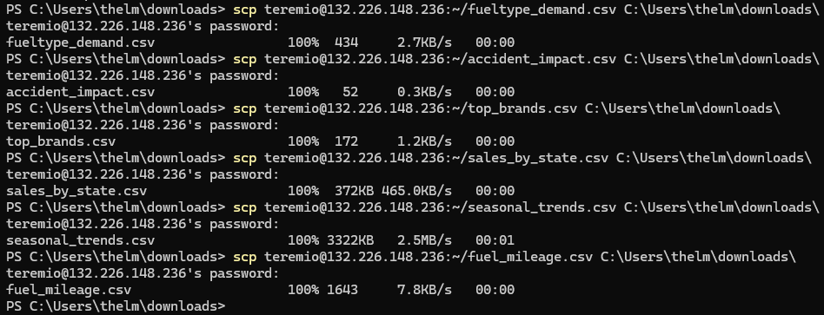
The files will now be in your local machine (located in downloads folder)
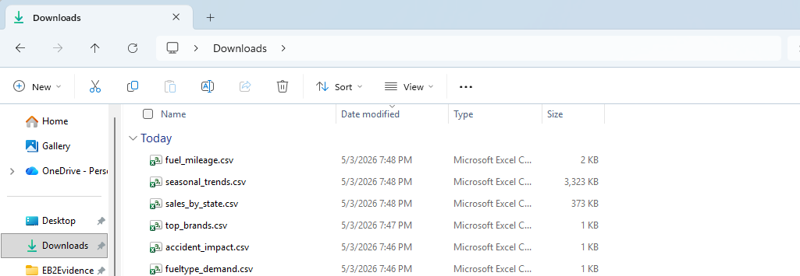

3. Visualization
- Distribution of Car Sales by State
- Open your excel first. Then open the file “sales_by_state.csv”. Then insert the first line with the following 17 column names: city latitude longitude total_listings avg_price avg_days_on_maket
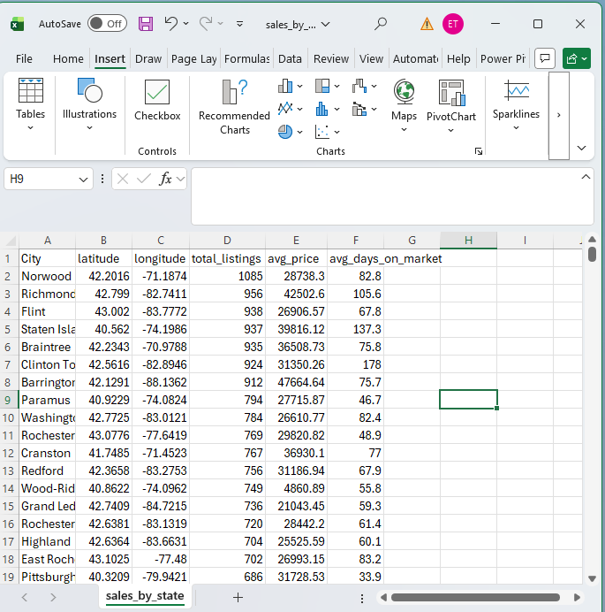
- Click on Home format as table check “my table has headers” Ok
- Click Insert 3D Maps
  - Set latitude to latitude
  - Set longitude to longitude
  - Drag total_listings to Height
  - Drag city to category
- Select heat map visualization
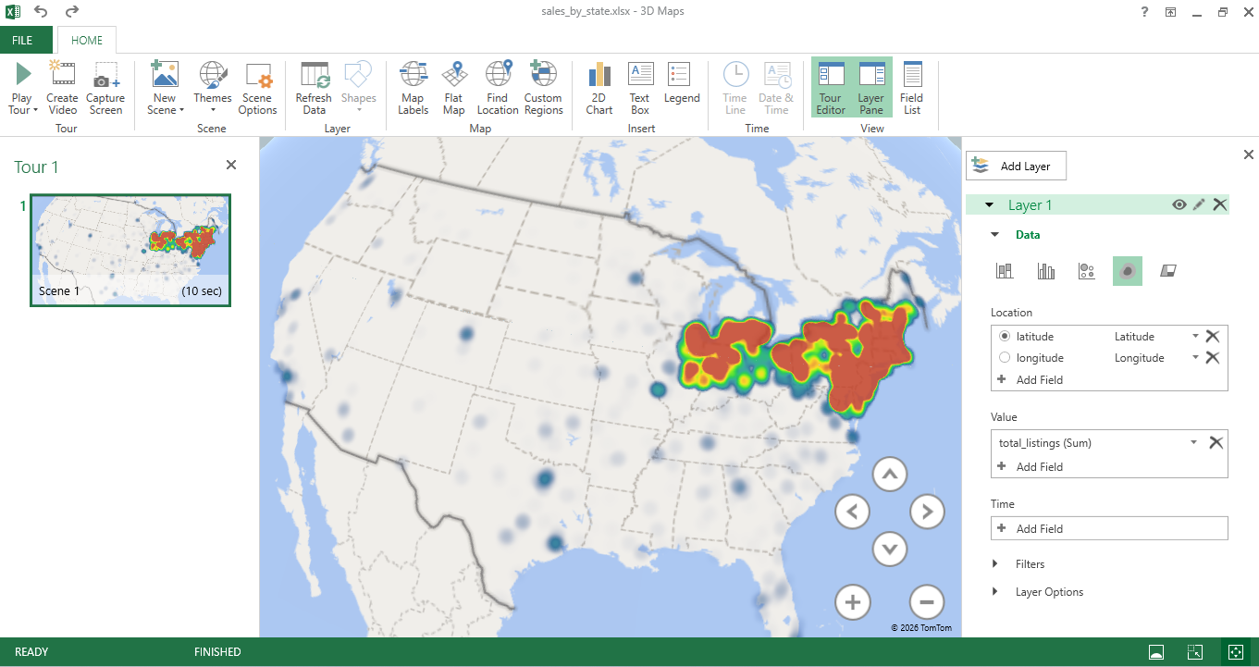
Summary: The heat map displays the distribution and concentration of used car sales across the United States with red/orange areas representing the highest concentration of listings and blue dots representing lower activity areas.
Northeast dominates The largest and most intense red cluster is concentrated in the Northeast corridor — covering areas like New York, New Jersey, Pennsylvania, and New England. This is clearly the hottest market for used car sales in the dataset, which makes sense given the high population density in that region.
Midwest activity There is a second significant cluster in the Midwest around the Great Lakes region — likely covering cities like Chicago, Detroit, and Cleveland. This suggests strong used car demand in that area as well.
Sparse activity elsewhere The South, West, and Southwest show much lower activity represented by the scattered blue dots. Cities like Houston, Dallas, Los Angeles and others appear as isolated dots rather than dense clusters.
What this means analytically:
- Used car listings are heavily concentrated in densely populated urban regions
- The Northeast and Midwest are the primary markets for used car sales in the US

- Demand by Brand (Top 10 Brands in the US)
- Open your Tableau to connect your server. You need to select Text File to open the file top_brands
- Rename F1: make_name, F2: total_listings, F3:avg_days_on_market
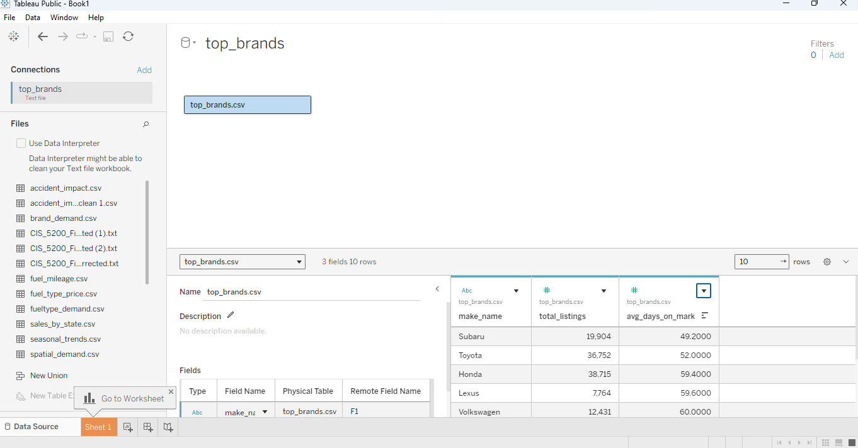
- Select sheet 1 next to data source
- Drag make_name to the Rows shelf at the top
- Drag avg_days_on_market to the Columns shelf (change measure from sum to avg)
- Show me select horizontal bar chart
- Click the sort descending button on the toolbar
- Drag avg_days_on_market to the Label card in the Marks panel (change measure from sum to avg)
- Change the format of the avg_days_on_market from 2 decimal to whole (0 decimal)
- Double click the chart title at the top and rename it "Top 10 Used Car Brands by Demand in the US"
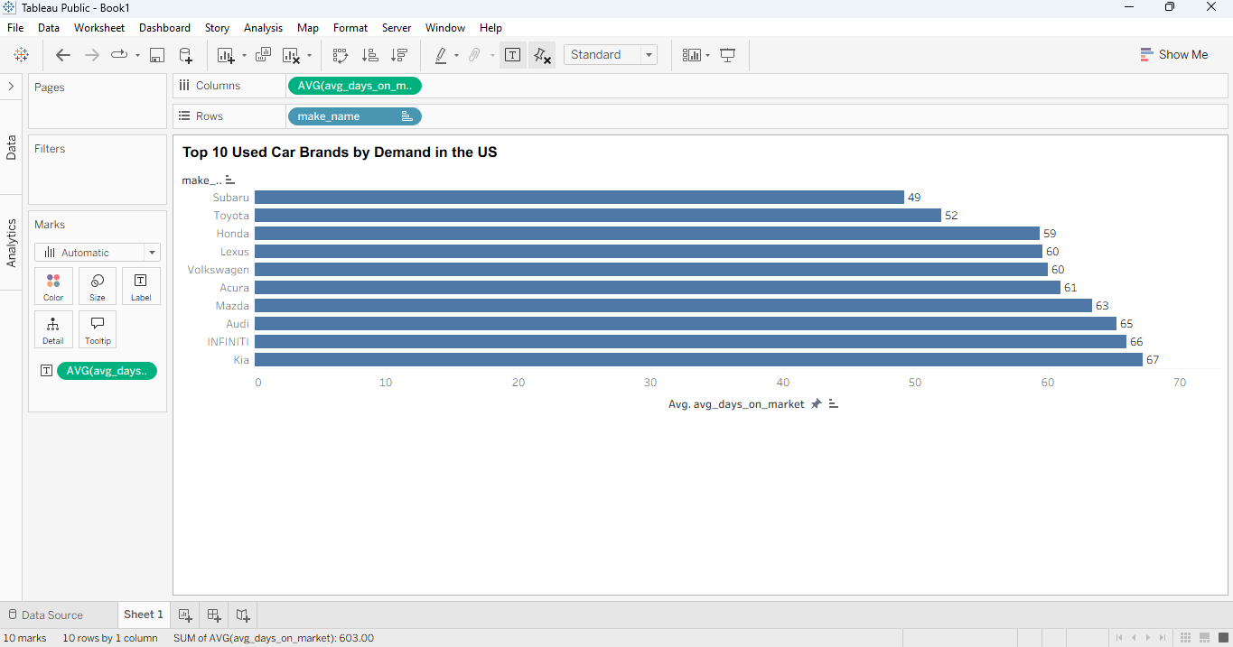

Summary: This horizontal bar chart displays the top 10 used car brands in the United States ranked by demand. Demand is calculated by the average days on market. The longer days on market shows low demand and the shorter days on the market shows higher demand.
Key Findings:
Subaru and Toyota lead demand with average days on market of 49 and 52 days respectively, meaning these brands consistently sell the fastest across the country. This suggests strong and loyal consumer bases for both Japanese automakers.
Honda and Lexus follow closely at 59 and 60 days, reinforcing the pattern that Japanese brands dominate the top of the demand chart — occupying 4 of the top 5 spots.
European brands like Volkswagen, Audi, and Infiniti fall in the middle range between 60 and 66 days, showing solid but slightly slower demand compared to Japanese counterparts.
Kia sits at the bottom of the top 10 at 67 days, still performing well overall but with relatively lower demand compared to the other brands.
Overall Insight: Japanese automakers dominate used car demand in the United States, likely driven by their strong reputation for reliability and fuel efficiency. This finding has practical implications for both buyers looking for fast-moving inventory and dealers trying to stock high demand vehicles.

- Accident History Impact on Price
- Open the accident_impact.csv file in Tableau and rename the columns using: has_accidents total_listing avg_price avg_days_on_market
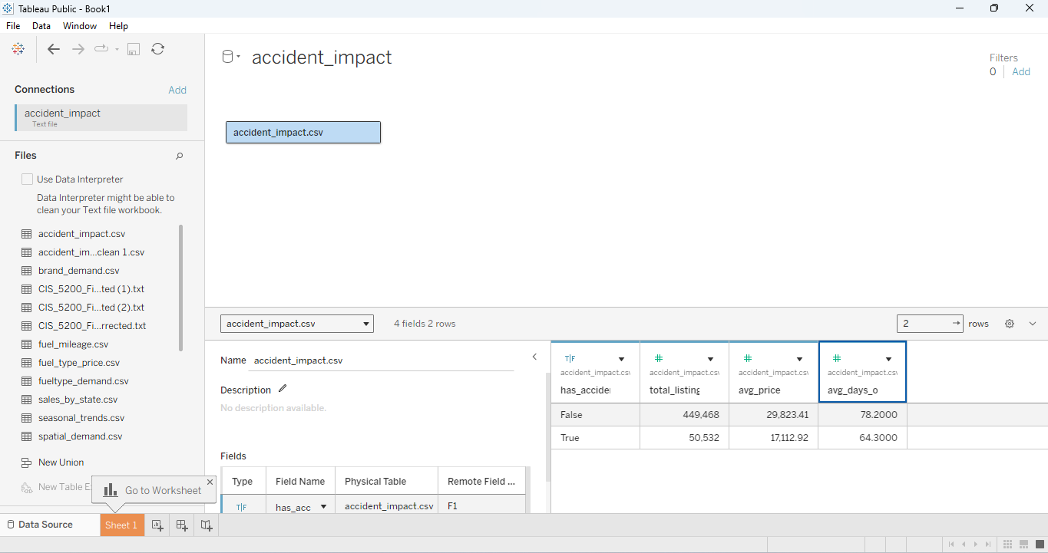
- Click sheet 1
- Drag has_accidents to the Columns shelf
- Drag avg_price to the Rows shelf (Change measure from sum to avg)
- Click the label button on the marks card and check show mark labels
- "Accident History Impact on Price”
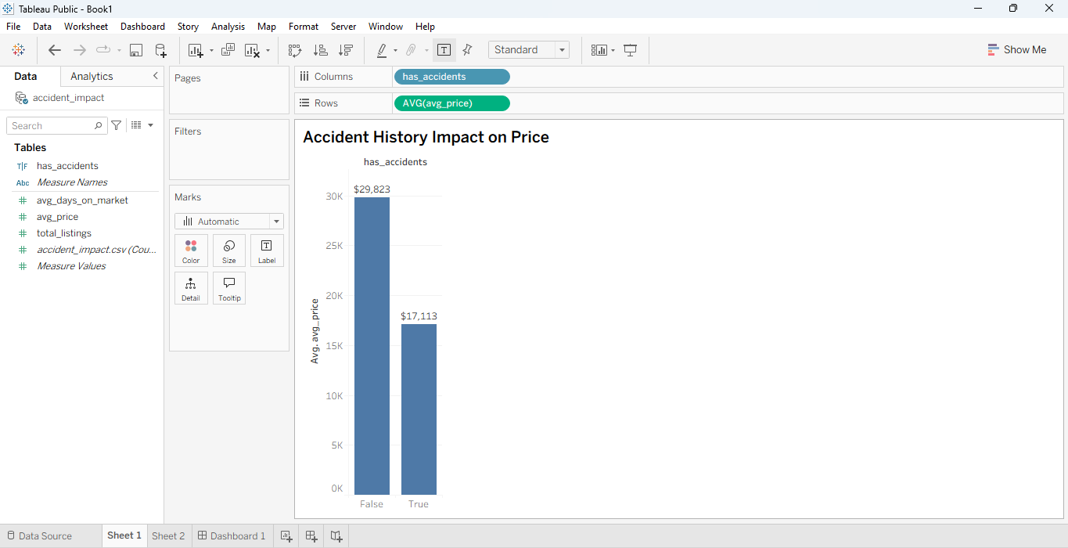
- Click on sheet 2
- Drag has_accidents to column and Drag avg_days_on_market to rows (change measure from sum to avg )
- Right click avg_price axis --> format --> set number format --> currency
- Click the label button on the marks card and check show mark labels
- Title it as: Average Price by Accident History
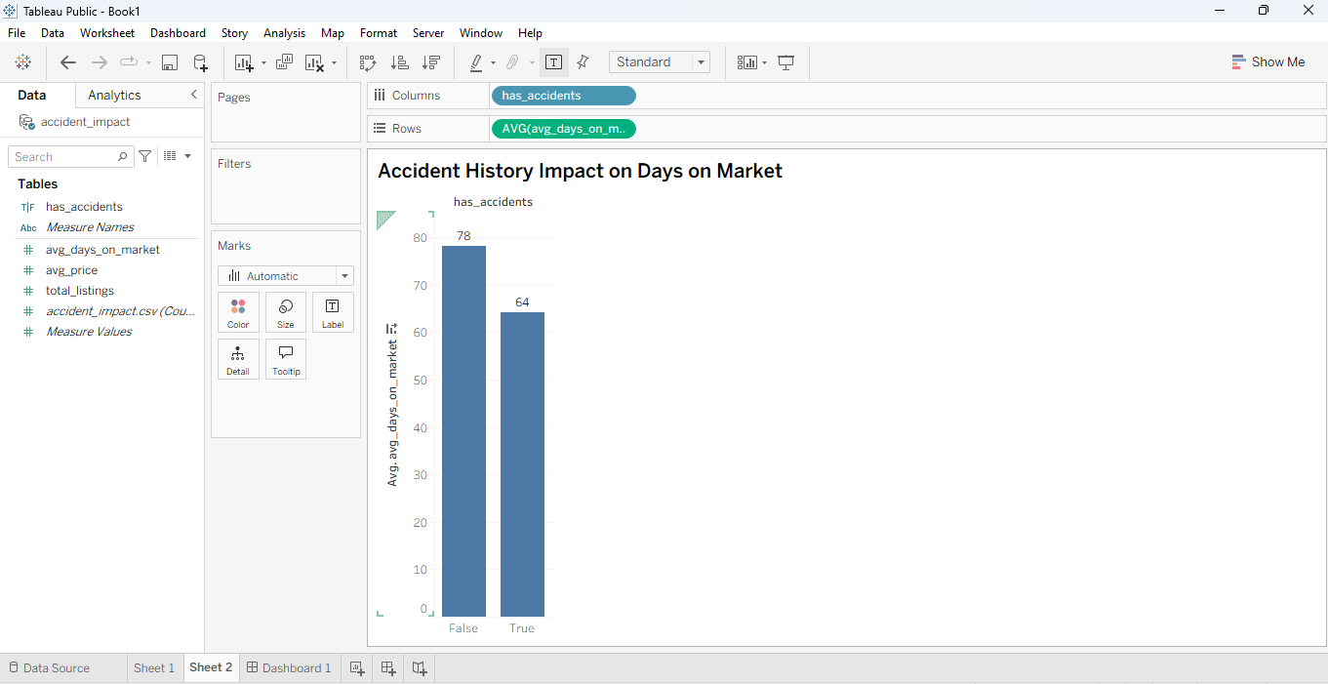
- Create a dashboard
- Drag sheet 1 and sheet 2 to the dashboard
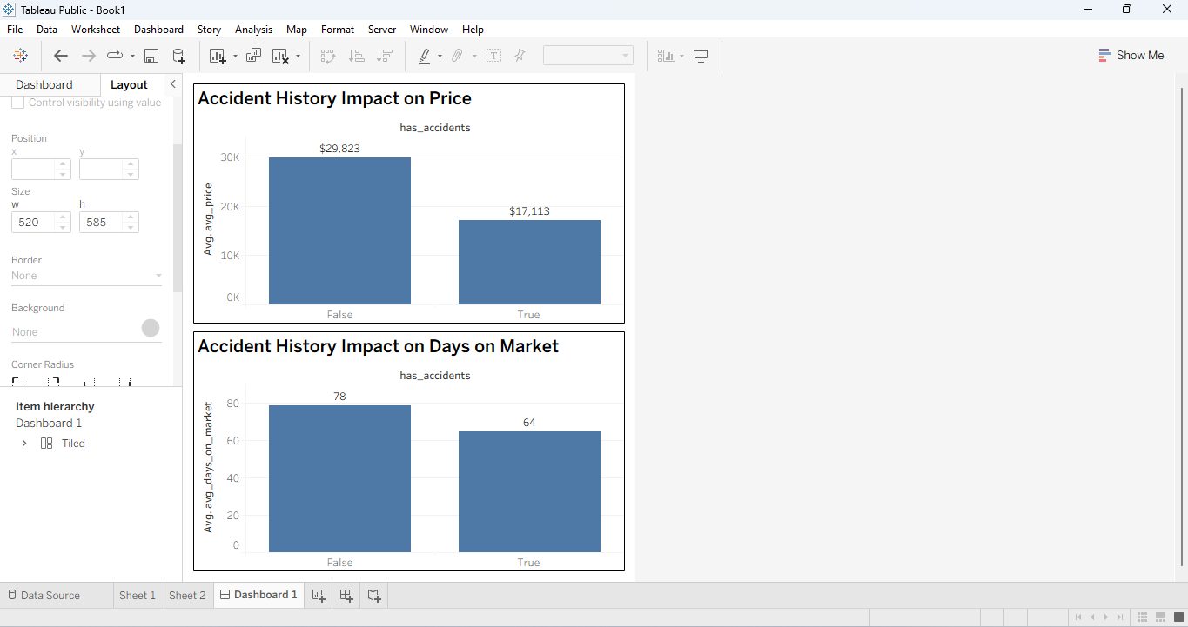
Summary:
These two charts together tell an interesting story about how accident history affects used car sales in two different ways — the price and how long it takes to sell.
On Price: Cars with no accident history sell for an average of $29,823 while cars that have been in an accident sell for an average of $17,113. That's a difference of nearly $13,000, meaning an accident history cuts a car's value almost in half. This makes a lot of sense because buyers naturally want a car that hasn't been damaged and are willing to pay a lot more for that peace of mind.
On Days on Market: Here's where it gets interesting, cars with accident history actually sell faster at 64 days compared to 78 days for clean cars. This might seem surprising at first but it actually makes sense when you think about it. The much lower price tag attracts budget conscious buyers who are willing to overlook the accident history in exchange for a significantly cheaper deal.
The Big Takeaway: Accident history doesn't stop a car from selling, it just changes who buys it and how much they pay for it. Sellers take a big hit on price but the car moves off the lot faster because the lower price attracts more budget conscious buyers quickly.
- Demand by fuel type
- Open Tableau and open fueltype_demand.csv file
- Rename as following: fuel_type listing_year total_listing avg_days_on_market
- Click Sheet tab at the bottom
- Drag listing_year to the Columns shelf
- Drag avg_days_on_market to the Rows shelf
- In the Marks panel click the dropdown that says Automatic Change it to Line
- Drag fuel_type to the Color card in the Marks panel
- Right click listing_year on the Columns shelf Click Dimension Discrete
- Right click avg_days_on_market on the Rows shelf Hover over Measure Change from Sum to Average
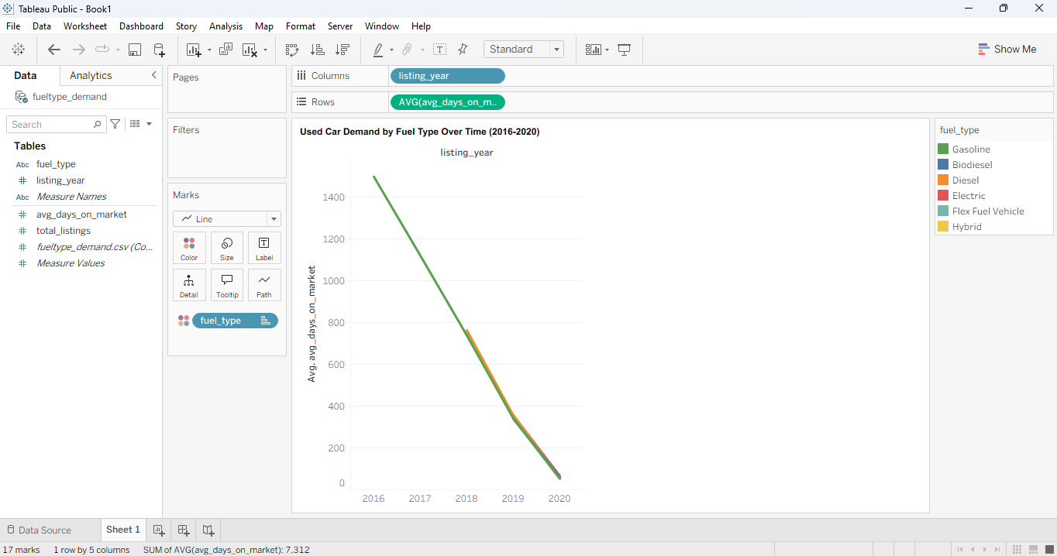
- Use filters to compare vehicle fuel types and demand (drag fuel_type to filters)
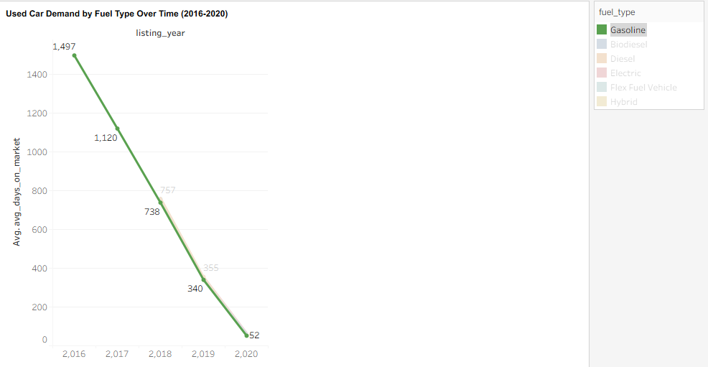
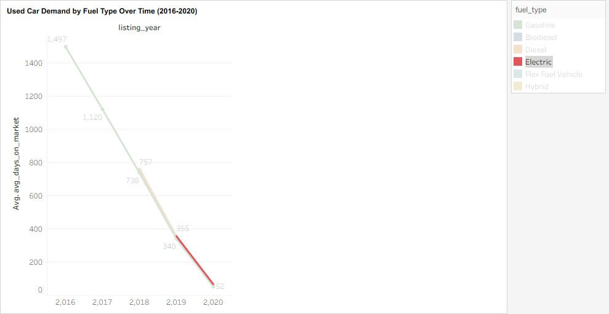
Summary: Going into this analysis, one of our biggest questions was whether the growing buzz around electric vehicles in recent years was actually translating into real consumer demand in the used car market. To find out, we tracked how quickly different fuel types were selling between 2016 and 2020 — because the faster a car sells, the more people want it.
What the data showed:
Gasoline continues to dominate the used car market by a wide margin. In 2016 gasoline vehicles were sitting on the market for about 1,497 days on average, but by 2020 that number dropped all the way down to just 52 days. That dramatic drop tells us that demand for gasoline vehicles grew incredibly fast over this period and shows no signs of slowing down.
For Electric vehicles, the story is a little more nuanced. Electric cars only started appearing in meaningful numbers from 2019 onwards in our dataset, and by 2020 they were selling at around the same pace as gasoline vehicles at roughly 52 days. That's actually really encouraging and suggests that electric vehicle demand is genuinely picking up steam.
The Big Takeaway:
While gasoline still rules the used car market, the speed at which electric vehicles are closing the gap is a strong early signal that consumer interest in EVs is real and growing. If this trend continues into 2021 and beyond, we could see electric vehicles becoming a much stronger force in the used car market in the coming years.

- Average price by fuel type and mileage
- Open Tableau Connect to your fuel_mileage.csv file
- Rename: fuel_type mileage_bucket total_listing avg_price avg_mileage
- Click Sheet tab to go to your worksheet
- Drag mileage_bucket to the Columns shelf
- Drag avg_price to the Rows shelf
- Drag fuel_type to the Color card in the Marks panel
- Right click avg_price on the Rows shelf Measure Change from Sum to Average
- Right click mileage_bucket on the Columns shelf Click Sort Select Manual and drag them into this order:
  - 0-20k
  - 20k-40k
  - 40k-60k
  - 60k-80k
  - 80k-100k
  - 100k+
- Drag avg_price to the Label card in the Marks panel
- Right click the label → Format Change format to Currency so numbers show with a $ sign
- Right click the Y axis Click Format Under Numbers select Currency
- Double click the title at the top and name: "How Mileage and Fuel Type Affect Used Car Prices"
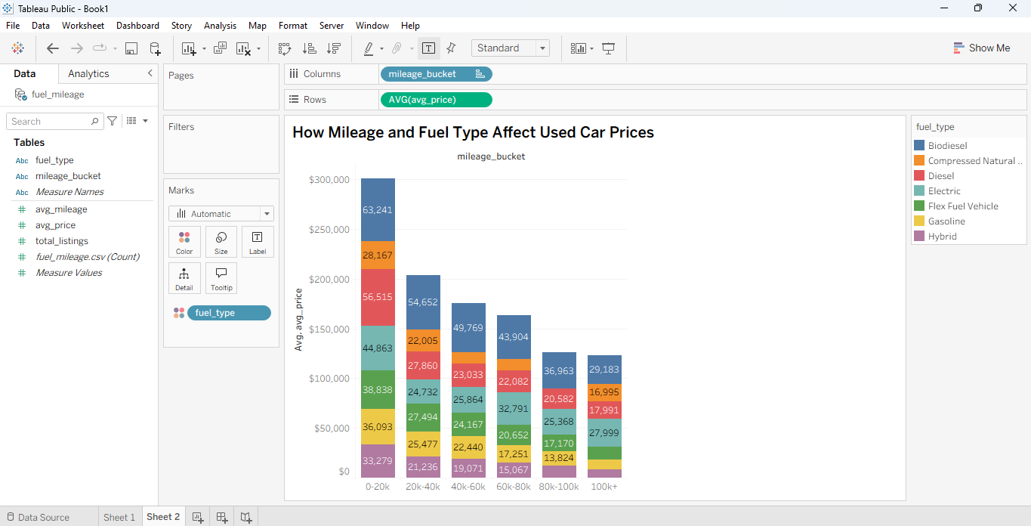

Low mileage cars are significantly more expensive — the 0-20k mileage bar reaches nearly $300,000 combined across all fuel types, dropping steadily as mileage increases. This confirms the obvious but important finding that fresher cars cost more.
Biodiesel (dark blue) commands the highest prices in the low mileage range at $63,241 — sitting at the very top of the 0-20k bar. This is surprising.
Electric vehicles (teal/green) maintain relatively consistent pricing even as mileage increases, which suggests EV buyers are less sensitive to mileage compared to gasoline buyers.
Gasoline (yellow) is consistently the most affordable across all mileage ranges, which makes sense given how abundant gasoline vehicles are in the market.
Price drops sharply after 60k miles across all fuel types — the bars get noticeably shorter from 60-80k onwards.

- Tempo spatial Analsyis (Seasonal Trends)
- Open your seasonal_trends.csv file in Excel
- Insert header and name: city latitude longitude listing_date total_listings avg_days_on_market demand_category
- Change file from csv to xlxs
- Format as a table Make sure "My table has headers" is checked → click OK
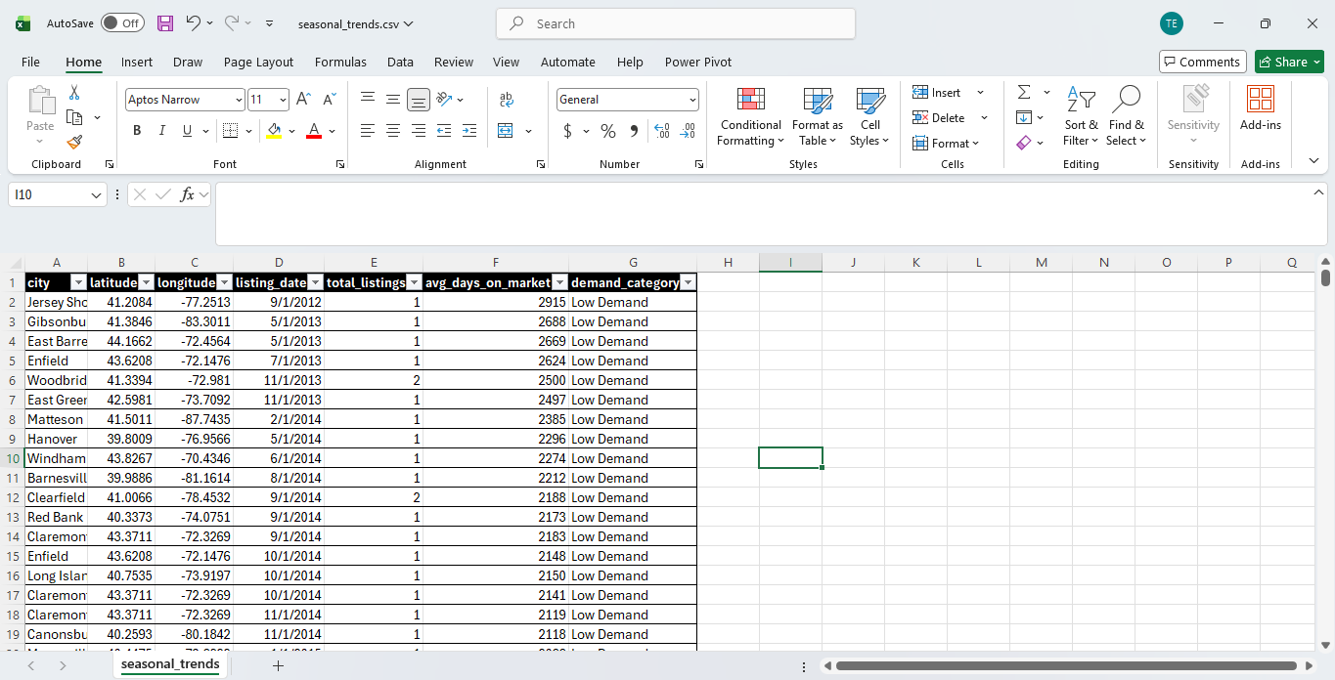
- Click the Insert tab at the top Click 3D Maps → Open 3D Maps
- Under Location
  - drag latitude to the Latitude box
  - Drag longitude to the Longitude box
- drag total_listings to the height
- drag listing_date to the time
- drag demand_Category to demand
- Click legend in the toolbar to showcase what each color means
- In the Layer Pane click second map
- In the Layer Pane click Filters
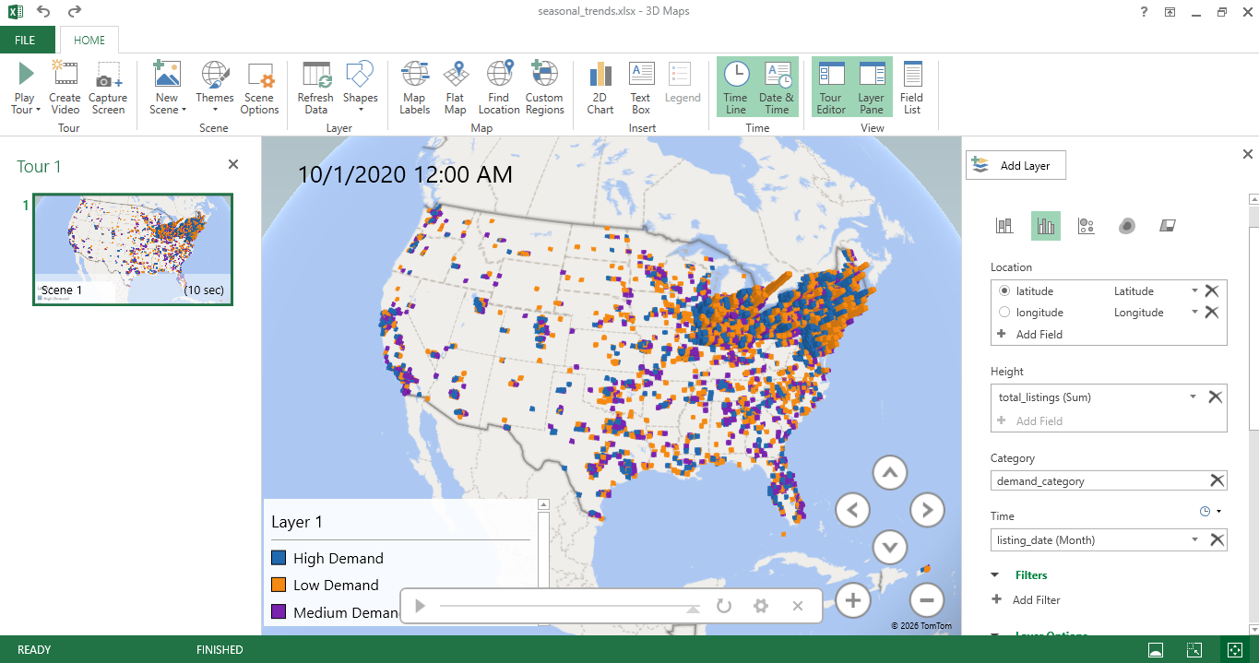

Summary: This animated map is our tempo-spatial visualization — it combines both location and time to show how used car demand shifts across the United States month by month. Each colored square on the map represents a city, and the time slider at the bottom moves the map through different months so you can watch demand patterns change over time.
What the colors mean:
- 🔵 Blue — High Demand — cars selling in under 20 days
- 🟠 Orange — Low Demand — cars taking longer than 45 days to sell
- 🟣 Purple — Medium Demand — cars selling between 20 and 45 days
What stands out:
The Northeast corridor is by far the most active region on the map, showing a dense concentration of all three demand categories. This confirms what we saw in our earlier spatial analysis — the Northeast is the heartbeat of the used car market in the US.
The Midwest shows consistent medium to high demand throughout the year, particularly around major cities like Chicago and Detroit.
The South and West are more spread out with lower overall activity, though certain cities like Miami and Los Angeles show noticeable spikes during specific months.
The tempo-spatial story: As the time slider moves through the months, you can see demand shifting and pulsing across the country — with certain regions heating up during spring and summer months and cooling down in winter. This seasonal pattern suggests that used car buyers are more active during warmer months, which is a trend that dealers and sellers could use to time their listings more strategically.

